YU SHING, LUI (A0201746)

Teesside University | 2020/21

BIG DATA AND BUSINESS INTELLIGENCE

cis4008-n-bf1-2020

Table of Contents

SECTION 1 – BUSINESS INTELLIGENCE DESIGN 2

1 Data Source Description and Business Questions 2

1.1 Dataset Information 2

1.2 Dataset Description 2

1.3 Business Questions 3

2 Data Pre-Processing and Data Cleansing 5

2.1 Renaming Columns 7

2.2 Changing Data Types 8

2.3 Removing Columns 10

2.4 Changing Format 12

3 Data Modelling – Star Schema Facts and Dimensions 16

3.1 Splitting tables 16

3.2 Remove Duplicate items 19

3.3 M Language and Create New Column 23

3.4 Data Model 27

3.5 Schema and Relationships 29

SECTION 2 – BUSINESS INTELLIGENCE SOLUTION 31

1 Executive Summary 32

2 Key Findings 32

3 Recommendations 33

4 Data Description 33

5 Data Model 33

6 Introduction 34

7 Finding based on analysis and evaluation – 1 34

7.1 Matrix and Key Finding From The Visual 34

7.1.1 DAX Expressions – 1 and New Calculated Measure Add Into Model 35

7.2 Key Performance Indicator (KPI) 38

7.2.1 Dax Expression - 2 39

8 Finding based on analysis and evaluation - 2 41

8.1 Infographic 41

8.2 Area Chart and Key Finding From The Visual 42

8.3 Treemap 43

8.4 Animated Chart 44

8.5 Map 45

8.6 Ask a Question Tool 47

9 Data Analytics (Forecast, Analysing trends) 48

9.1 Forecast 48

9.2 Artificial Intelligence And Key Finding From The Visual 50

10 Structure of the Dashboard 51

11 Conclusion 53

12 Recommendations 53

13 Personal Conclusions 53

14 Reference 54

# SECTION 1 – BUSINESS INTELLIGENCE DESIGN

# 1 Data Source Description and Business Questions

## 1.1 Dataset Information

The dataset is about coffee house chain in United States of America. The dataset focus of this project as it contains important information with over 4,000 rows and 20 columns. The columns of the dataset is including Area Code, Date, Market, Market Size, Product, Product Line, Product Type, State, Type, Budget Cost of Goods Sold, Budget Margin, Budget Profit, Budget Sales, Cost of Goods Sold, Inventory, Margin, Marketing, Profit, Sales, and Total Expenses.

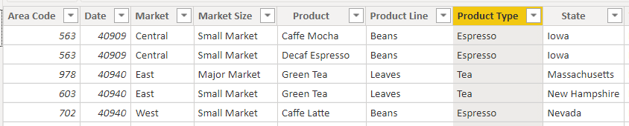

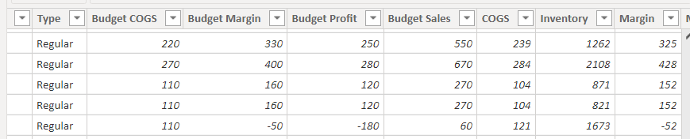

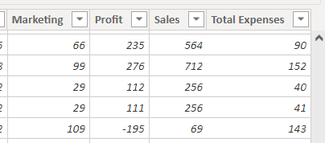

## 1.2 Dataset Description

The dataset is for the coffee chain that take place in the different states of United States of America and each type of product’s statistics in 2012-2013. It is taken from the webpage, www.dataplusscience.com, and the total weight of the data is 403kb in excel file.

The dataset is downloaded as below linkage.

(<http://www.dataplusscience.com/files/Coffee.xlsx>)

## 1.3 Business Questions

Why did you select this specific dataset?

This specific dataset is common in the commercial industry to analysis the company’s sales and revenue in different sectors. We believe that it can train us to use Power BI to solve lots of problems once we face the same issue in our career.

Will this dataset help you in developing specific business skills?

This dataset can develop specific business skills, which is like Data Analysis, Communication, Problem Solving.

Data Analysis – The dataset will translate into actionable information, then the management team can make decision that will enhance profitability as much as possible. It will involve large amount of data and it can help to practice analytical skills.

Communication – Practicing how to describe this data, explain the result from data analysis, and then provide possible solutions and forecast. It is one of the most critical soft skill in commercial industry.

Problem Solving – Analysing this data is just part of the data analyst’s skill, who also offer solutions to management team based on the dataset. Therefore, it is necessary come up with clear suggestions and high accuracy forecast to assist the company make better decisions.

What questions do you seek to answer with your BI project?

* What is the overall on an average sale of the products?
* What is the sales variance of each products?
* What are the total expenses versus profit for each product?
* What is the market size for each state with their sales?
* How is the key performance indicator of sales, profit and cost of goods sold?
* How is the sales forecast in 2014?

Which specific features are you going to focus on?

Interactive Power BI Desktop – It allows to build reports by accessing the data rapidly, even people do not have advanced skills to create a report with Power BI. This tool is free to download, and allow everyone to create report without processing any technical knowledge.

Customized Visualization – Power BI has a default standard, and it can customize some functions to process some complex data depends on everyone required. It can access the custom library of visualization easily and design a visualization that serves the people need.

Visibility – Making the data meaningful is the main purpose. Power BI can help to deliver actionable insights and simplify the task of data collaboration, analysis, and makes it to next high-standard level.

Does this dataset address the Big Data problem?

This dataset can address the big data problem. It requires to clean, edit and organise this data, then manage this dataset in Power BI and turn data into visualisation for the company. In addition, use it to provide valuable insights to management team and they can make decisions.

# 2 Data Pre-Processing and Data Cleansing

Power BI Desktop is able to input with different data source, which is like Excel, Text/CSV, Web, etc.

Loading data to the Power BI

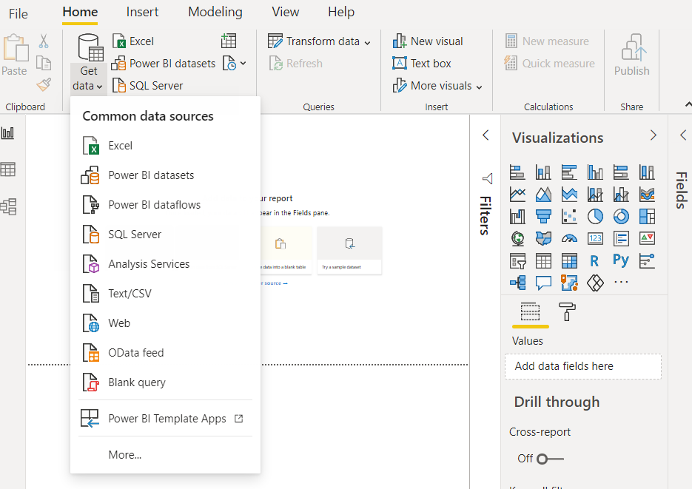

Selecting the data file ‘Sheet 1’ and click the load button to load the data.

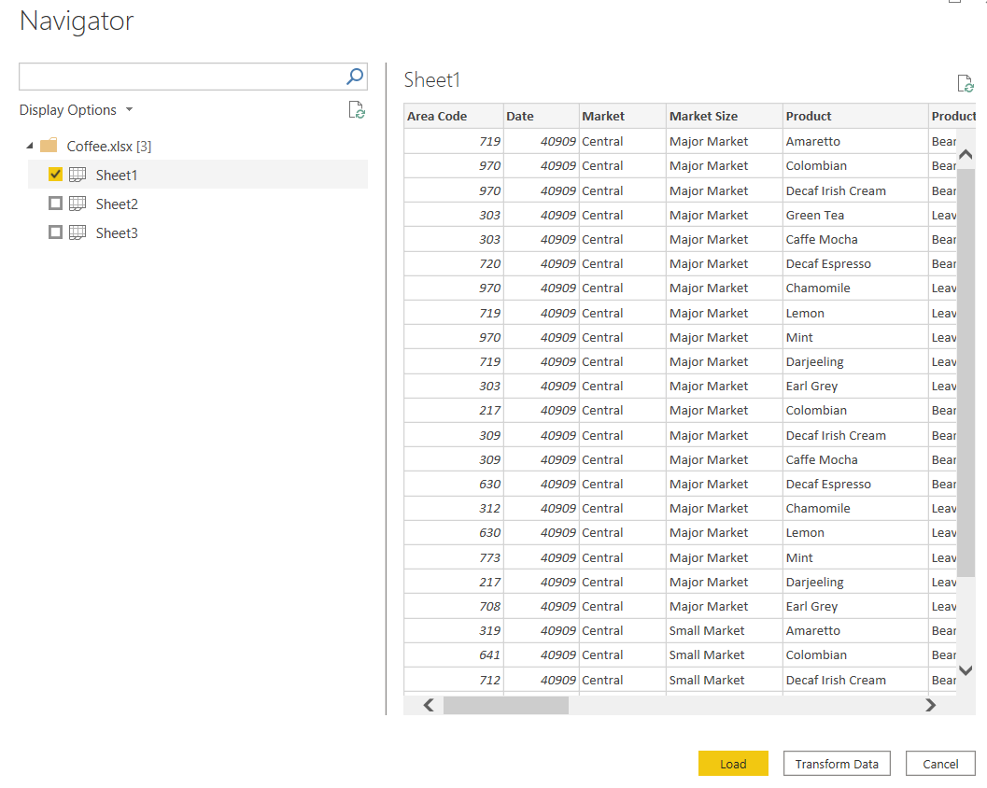

## 2.1 Renaming Columns

Once the data is loaded, double-click specify columns to rename in the “Fields” section. Now change the name of columns “Budget COGS” to “Budget Cost of Goods Sold”. Then use the same steps to change the two columns “COGS” and “Type” to “Cost of Goods Sold” and “Caffeine Type”.

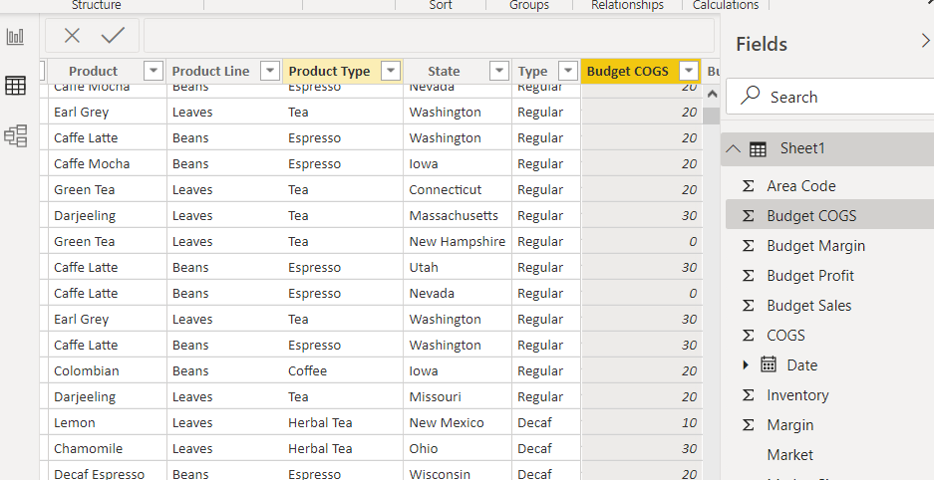

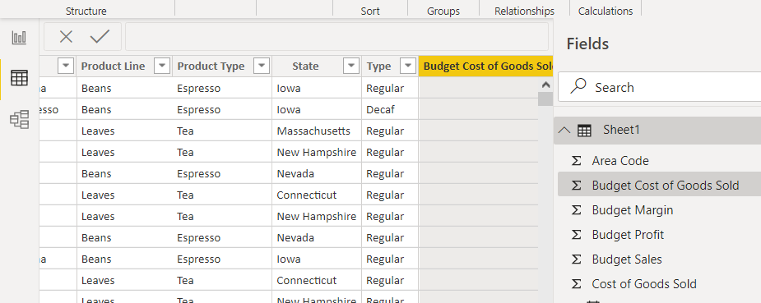

## 2.2 Changing Data Types

After changing the name of columns, the next step is change the data type in “Transform Data”.

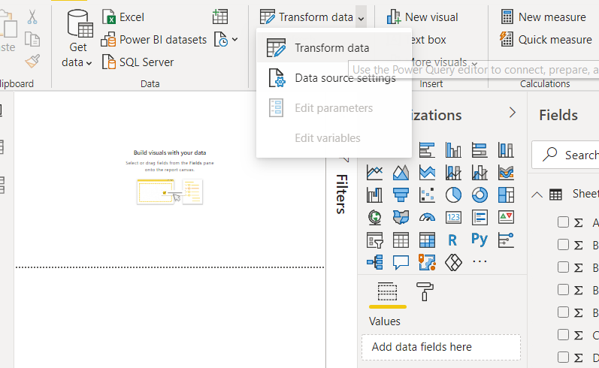

Click the logo which is located in the left of the name’s column and change to “Date”.

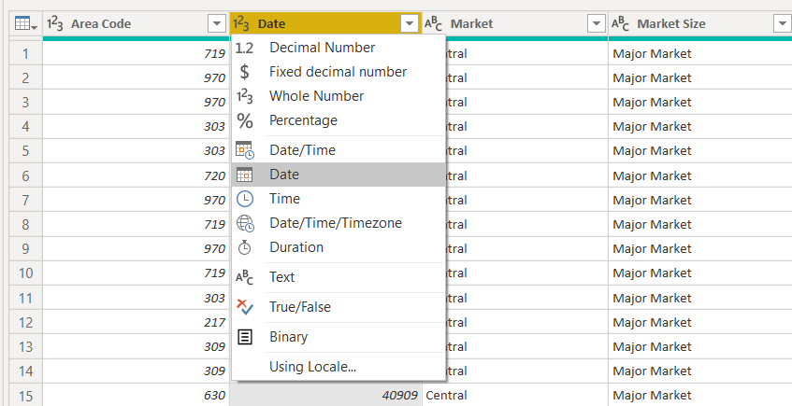

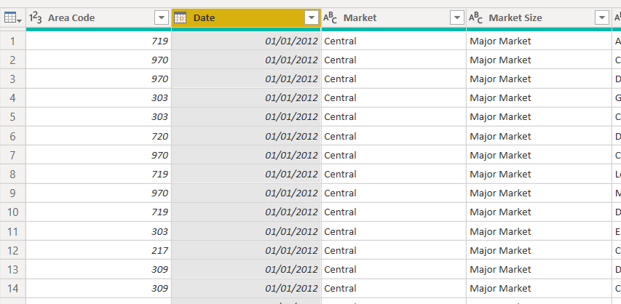

## 2.3 Removing Columns

Also, the value of “Marketing” column is not necessary and we should delete it. Right-click of the column and select “Remove”. After that, click “Close & Supply” to save the changes.

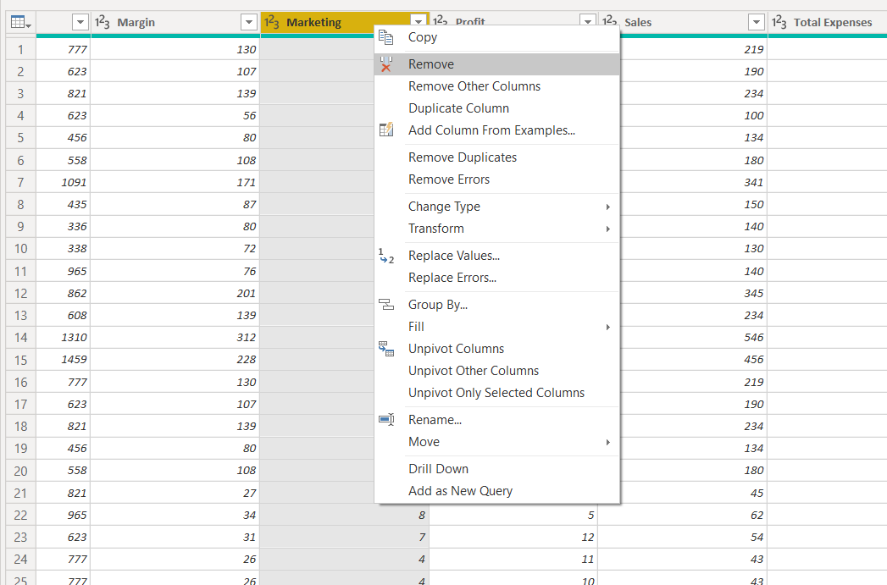

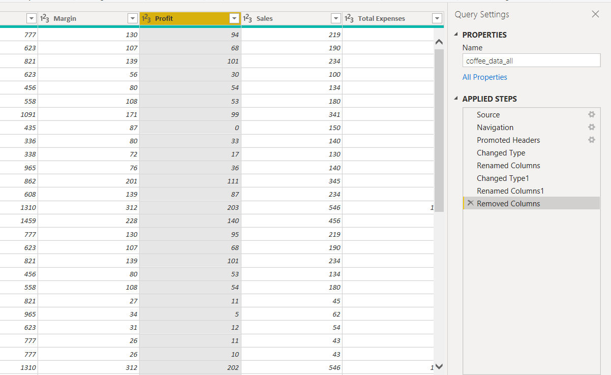

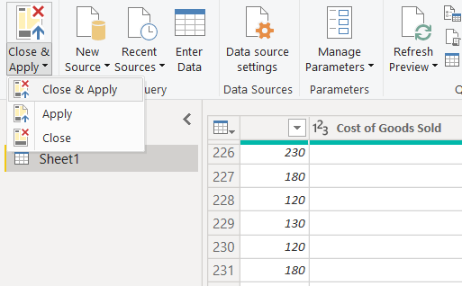

## 2.4 Changing Format

After all the adjustments, move to select “Data” section on the left and click to highlight “Date” column. Select “Formatting” and revise the format to “(mmmm yyyy)”.

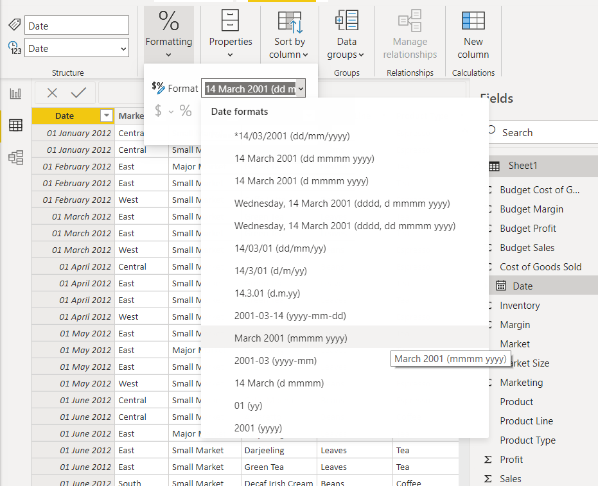

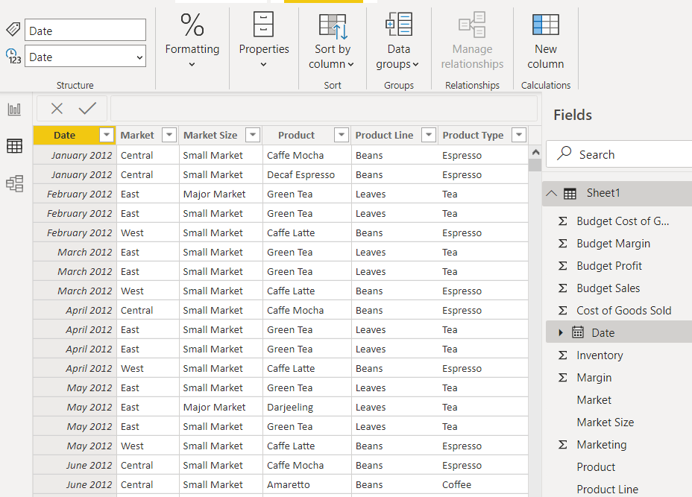

Changing the format of “Budget Cost of Goods Sold” column from “Whole Number” to “Currency” and add common currency symbols to “$ English (United States). Also, change decimal places to “0”. Repeat the same step for the rest of columns of Budget Margin, Budget Profit, Budget Sales, Cost of Goods Sold, Inventory, Margin, Marketing, Profit, Sales, and Total Expenses.

# 3 Data Modelling – Star Schema Facts and Dimensions

## 3.1 Splitting tables

In this dataset, try to split seven tables to normalise data. So, click “Transform data” and the “Power Query Editor” come up. After that, right-click “Sheet1” in Queries section and duplicate six tables for further usage.

Right-click “Sheet1” in the Queries section and choose “Rename”. Change the name from “Sheet1” to “coffee_data_all”.

Repeat all the same steps and change the rest of sheet’s name to “product”, “product_type”, “product_caffeine”, “Market_size”, Area_code”, State”.

## 3.2 Remove Duplicate items

Once select “product” column, there are many duplicates items in the “Product” column and need to remove all of it because it can prevent many-to-many relationship happen. So, right-click “Product” column and choose “Remove Duplicates”.

Repeat the same steps for the rest of columns. Then click “Close & Apply” to save all the changes.

## 3.3 M Language and Create New Column

The following paragraph will describe a few steps to create a calendar table by day, year, quarter, week number, month number, month, and day of week.

In the left-hand side of queries, right-click and create “Blank Query”. Choose “Advanced Editor” and write the following code in Query1.

#create date dimension

**(StartDate as date, EndDate as date)=>**

**let**

#date ranges from parameters

**StartDate = #date(Date.Year(StartDate), Date.Month(StartDate),**

**Date.Day(StartDate)),**

**EndDate = #date(Date.Year(EndDate), Date.Month(EndDate),**

**Date.Day(EndDate)),**

#the number of dates required for the table

**GetDateCount = Duration.Days(EndDate - StartDate),**

#Take count of dates and get it into a list of dates

**GetDateList = List.Dates(StartDate, GetDateCount,**

**#duration(1,0,0,0)),**

#Convert the list into a table

**DateListToTable = Table.FromList(GetDateList,**

**Splitter.SplitByNothing(), {"Date"}, null, ExtraValues.Error),**

#Add year column

**YearNumber = Table.AddColumn(DateListToTable, "Year",**

**each Date.Year([Date])),**

#Add quarter number column

**QuarterNumber = Table.AddColumn(YearNumber , "Quarter",**

**each "Q" & Number.ToText(Date.QuarterOfYear([Date]))),**

#Add week number column

**WeekNumber= Table.AddColumn(QuarterNumber , "Week Number",**

**each Date.WeekOfYear([Date])),**

#Add month number column

**MonthNumber = Table.AddColumn(WeekNumber, "Month Number",**

**each Date.Month([Date])),**

#Add month column

**MonthName = Table.AddColumn(MonthNumber , "Month",**

**each Date.ToText([Date],"MMMM")),**

**in**

**DayOfWeek**

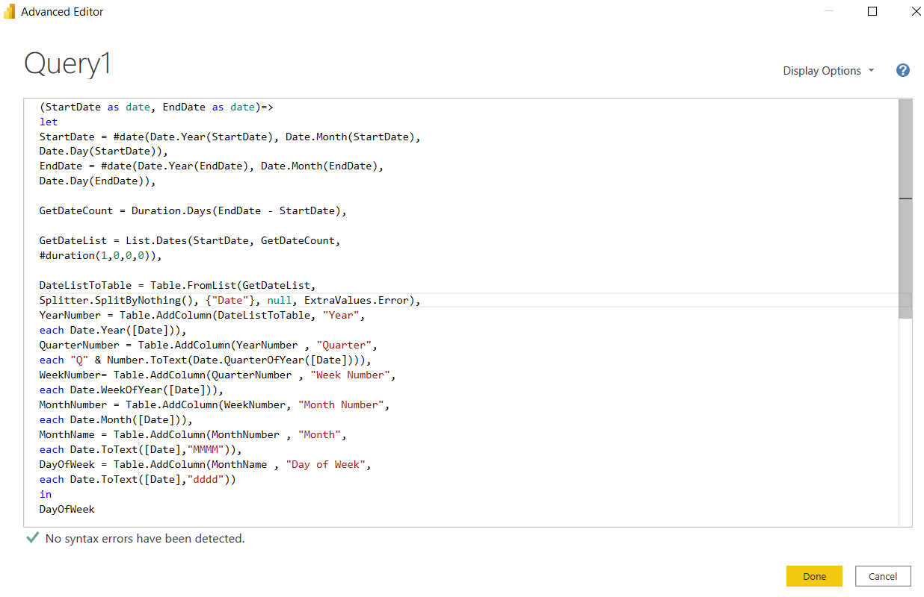

Once click “Done”, parameters are required to input the date. According to our dataset, the start date is 01/01/2012, and the end date is 31/12/2013.

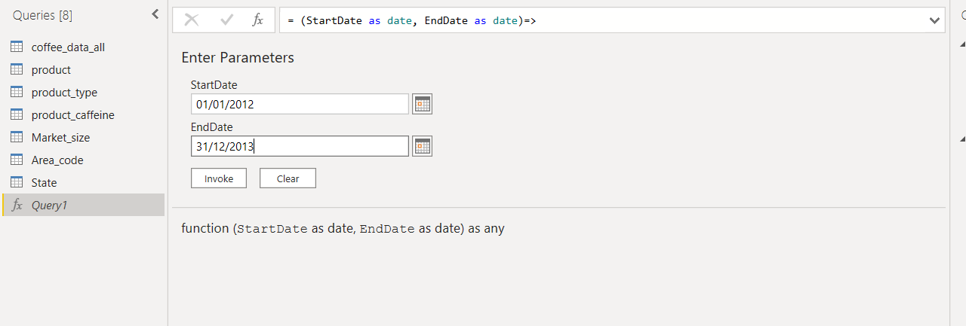

The new table is created in “Queries” and rename the table as “Calendar”. Change the first column of type to “Date” for further usage.

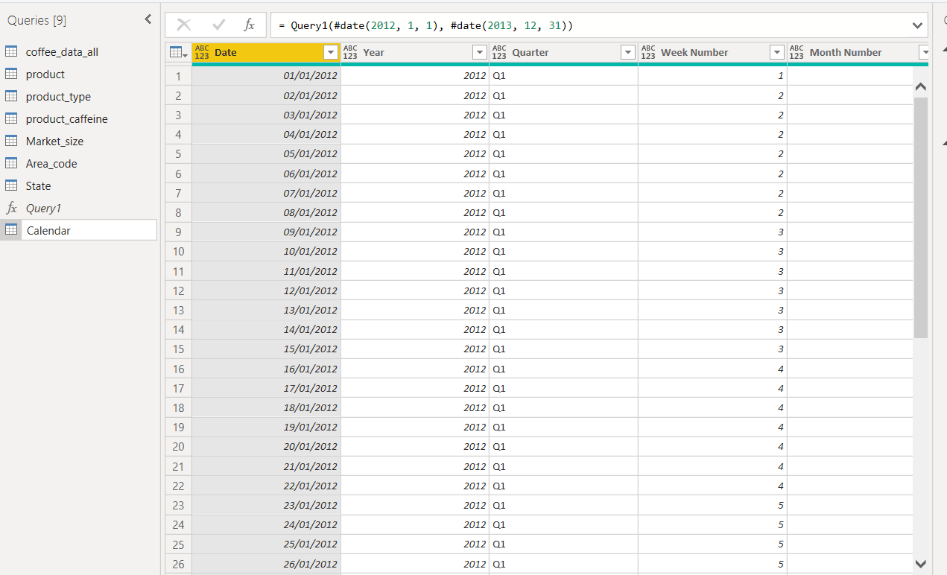

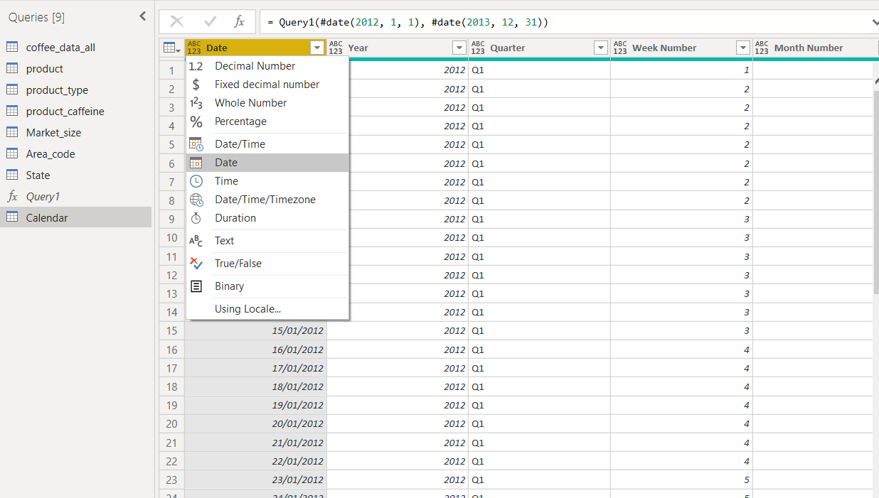

## 3.4 Data Model

Now look at the “Model” section, which are eight tables. It shows their structure for each table as below.

1. Market_size

|  |  |
| --- | --- |
| Column | Description |
| Market Size | Market size of USA |

1. State

|  |  |
| --- | --- |
| Column | Description |
| State | State name of USA |

1. Area_code

|  |  |
| --- | --- |
| Column | Description |
| Area Code | Area code of USA |
| State | State name of USA |

1. Product_caffeine

|  |  |
| --- | --- |
| Column | Description |
| Caffeine Type | Type of caffeine of products |

1. product_type

|  |  |
| --- | --- |
| Column | Description |
| Product Type | Type of products |

1. product

|  |  |
| --- | --- |
| Column | Description |
| Product | Name of products |
| Product Line | Original material of products |
| Product Type | Type of products |
| Caffeine Type | Type of caffeine of products |

1. Calendar

|  |  |
| --- | --- |
| Column | Description |
| Date | Date of purchasing |
| Year | Year of purchasing |
| Quarter | Quarter of purchasing |
| Week Number | Week number of the year |
| Month Number | Month number of the year |
| Month | Month of the year |
| Day of Week | Day of week of the year |

8) coffee_data_all

|  |  |
| --- | --- |
| Column | Description |
| Date | Date of purchasing |
| Market | Location of market |
| Market Size | Size of market |
| Product | Name of products |
| Product Line | Original material of products |
| Product Type | Type of products |
| State | Location of state in USA |
| Caffeine Type | Type of caffeine of products |
| Budget Cost of Goods Sold | Budget cost of goods sold |
| Budget Margin | Budget margin of products |
| Budget Profit | Budget profit of products |
| Budget Sales | Budgets sales of products |
| Cost of Goods Sold | Cost of goods sold |
| Inventory | Inventory of products |
| Margin | Margin of products |
| Marketing | Marketing expenses of products |
| Profit | Profit of products |
| Sales | Sales of products |
| Total Expenses | Total expenses of products |

## 3.5 Schema and Relationships

We can find that all tables have not any relationship and Star schema format will be used to create relationship and link up together. In the dataset, “coffee_data_all” table is the main one and it relates with all other tables.

For creating relationship with “product” and “coffee_data_all”, click “Product ” of “product” table, then hold and drag to “Product” of “coffee_data_all” table.

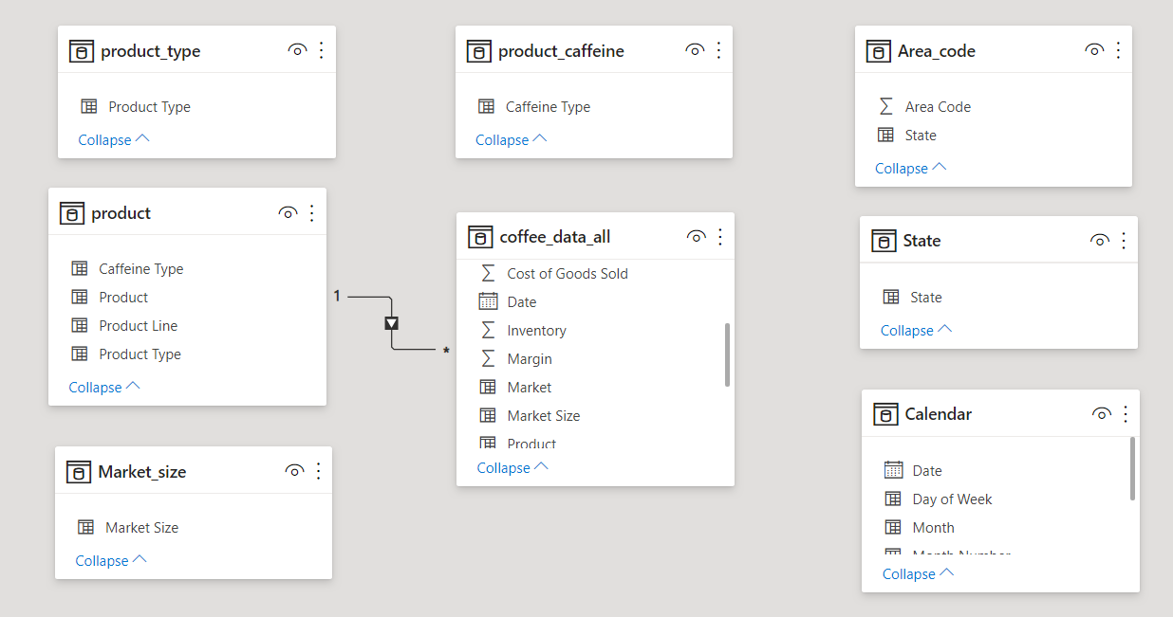

Use the same steps for the rest of the model, and look at the relationship as below. As all tables of duplicated items are removed before, so it do not have any many-to-many relationship issue happened.

# SECTION 2 – BUSINESS INTELLIGENCE SOLUTION

**COFFEE CHAIN ANALYSIS IN 2012-2013**

# 1 Executive Summary

Background – Coffee is one of most important beverages for most people during the day. Believe that it should be a huge market over the world and specially people who live in North America. The dataset of coffee chain house is the best choice and create data visualisation to identify data patterns. Exploring this dataset and find out an underlying issue. Sales amount, profit, expense for each product in different states will be a main concern which it will focus on.

The aim of this report will provide vital sights on how to improve the sales volume and profit. Sales and marketing team can setup marketing plan and sales strategy based on this business report to improve overall revenue.

# 2 Key Findings

* Most of tea product’s sales volume is better than expected and it has over 15% positive variance. However, coffee product’s performance is totally out of expectation and some product’s sales volume are also overestimated.
* The profit margin of coffee products is much better than tea products. The profit of Colombian and Regular Espresso nearly double of total expenses.
* The state of Iowa is a small market compare with other big cities, but the profit volume is much better the other major market, like Florida and New York.
* Caffe Mocha is the most popular product in the major market of Illinois in 2012 and 2013.

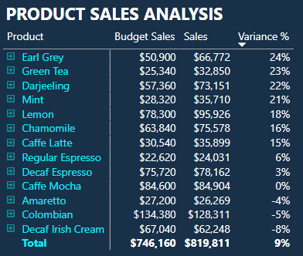

# 3 Recommendations

* Boosting sales of coffee products.
* Finding the solutions to control the cost of tea products.
* Providing suggestion for the market team about the marketing plan.

# 4 Data Description

The dataset is for the coffee chain that take place in the different states of United States of America and each type of product’s statistics in 2012-2013. It is taken from the webpage, www.dataplusscience.com, and the total weight of the data is 403kb in excel file.

# 5 Data Model

The data model is shown as below and the table of “coffee_data_all” is the key element with all the other table. Basically, it separates with products type, product, market size, caffeine type, area code, state, and calendar.

# 6 Introduction

The business report is including three sections, which are sales summary, sales insight, and sales forecast and artificial intelligence. The following section will describe of this dataset and provide some basic understanding to target audience. Then the other section will compare the data between 2012 and 2013, which it will find some insights of different states. For the last section, it tries to forecast the upcoming sales volume and use artificial intelligence tool to find out some relationships with sales aspect.

# 7 Finding based on analysis and evaluation – 1

## 7.1 Matrix and Key Finding From The Visual

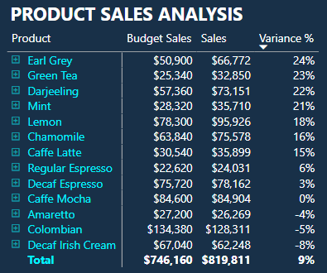

It mentioned before in the key finding for this chart. It shows the variance of budget sales and sales with each product. Most of tea product’s sales volume is better than expected and it has over 10% positive variance. However, coffee product’s performance is totally out of expectation and some product’s sales volume are also overestimated.

### 7.1.1 DAX Expressions – 1 and New Calculated Measure Add Into The Model

The percentage of variance is good to illustrate about the difference. However, it requires to create a new column of the model in the Data section and use DAX language to calculate the variance of sales. The formula shows the value of sales subtracts budget sales and it is shown as below.

**Variance of Sales = coffee_data_all[Sales]-coffee_data_all[Budget Sales]**

Then, move back to report section that create a new measure and input the formula to calculate the percentage of variance between the budget sales and sales. The formula is shown as below.

**Variance % = (sum(coffee_data_all[Sales]) - SUM(coffee_data_all[Budget Sales])) / SUM(coffee_data_all[Sales])**



We have to sum up the total of sales and subtract the sum of the budget sales, then divide by the sum of sales again. After that, change the format from “General” to “Percentage” for this measure.

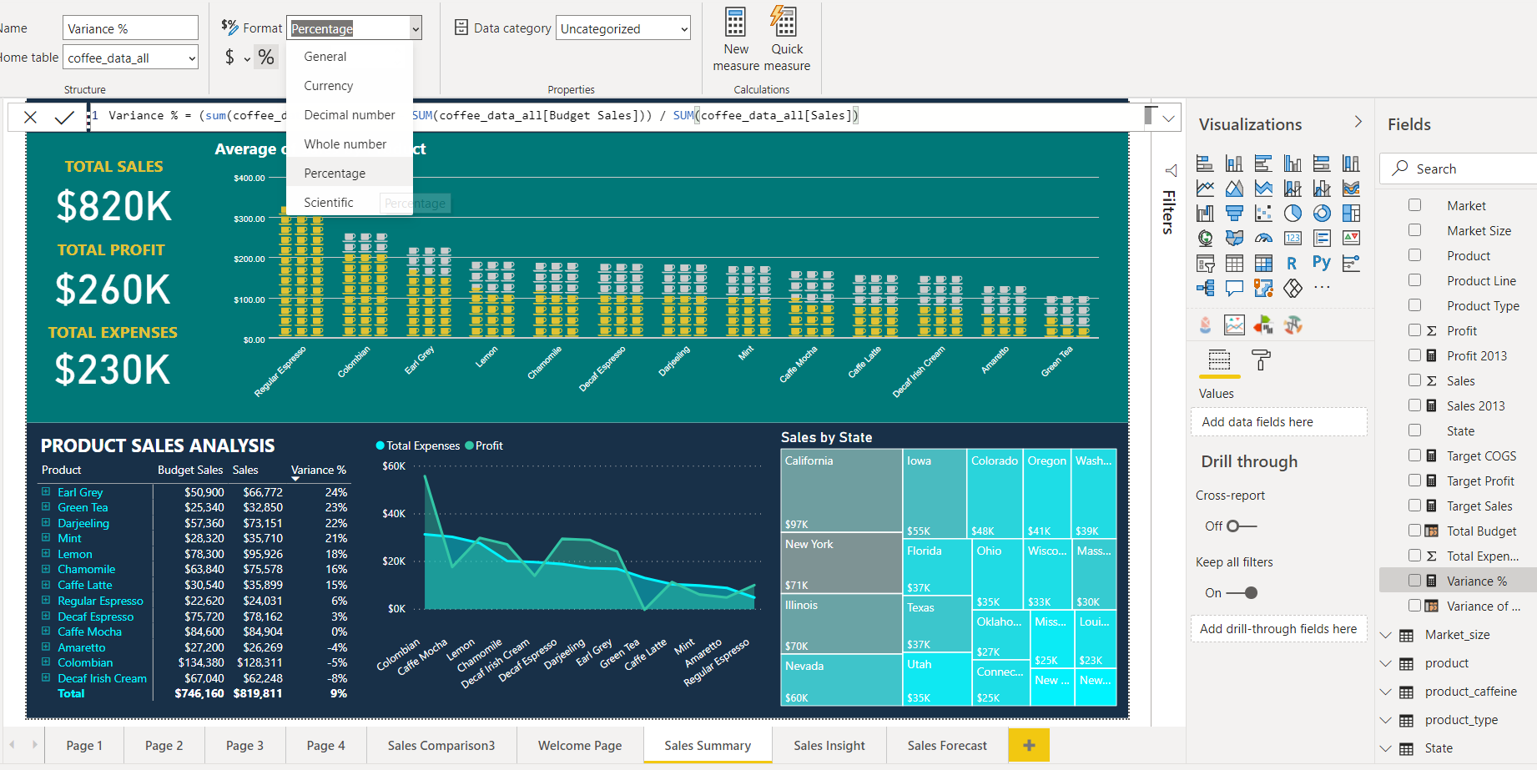

## 7.2 Key Performance Indicator (KPI)

Key Performance Indicator (KPI) can evaluate whether the current value is fulfilled our target or not. For a KPI visual, setup the target measure or value is necessary and compare the current value.

For the next graph, it will investigate a KPI of the Sales, Profit and Cost of goods sold in 2013. It will set the goal for each of value and it also have to write a formula in DAX language to filter the data for 2013 only.

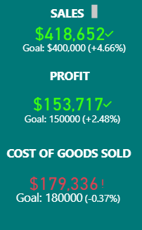

### 7.2.1 Dax Expression - 2

There are three KPI graphs to illustrate Sales and Profit are completed the goal and Cost of goods Sold is almost fulfilled the target. For those KPI setting, we create three measures and input the formulas as below:

**Sales 2013 = CALCULATE(SUM(coffee_data_all[Sales]), DATESBETWEEN(coffee_data_all[Date],DATE(2013,1,1),DATE(2013,12,31)))**

**Profit 2013 = CALCULATE(SUM(coffee_data_all[Profit]), DATESBETWEEN(coffee_data_all[Date],DATE(2013,1,1),DATE(2013,12,31)))**

**COGS 2013 = CALCULATE(SUM(coffee_data_all[Cost of Goods Sold]), DATESBETWEEN(coffee_data_all[Date],DATE(2013,1,1),DATE(2013,12,31)))**

Those formulas calculate the sum of Sales, Profit and Cost of goods Sold. Then use “DATEBETWEEN” function to filter the period as we required.







After that, it should be put those measures into “Indicator” and remember to set the target goal as required for KPI.

# 8 Finding based on analysis and evaluation - 2

## 8.1 Infographic

It can show about the information of the average of sales by product. Regular expresso is very popular product, which the average sales is over $300 USD. However, green tea is not many people to buy and it has around $100 USD sales only.

## 8.2 Area Chart and Key Finding From The Visual

This data is also mentioned in the key finding before. Looking at the relationship with total expenses and profit in this chart. The profit margin of coffee products is much better than tea products. The profit of Colombian and Regular Espresso nearly double of total expenses. Also, it indicates some products lose profit, which is Caffe Mocha, Decaf Irish Cream, or Green Tea etc.

## 8.3 Treemap

It represents the relationship with Sales and State in the treemap. California, New York, and Illinois are the highest sales in USA. If decision maker desires to find the other states, they can start exploring from left to right and up to down with descending order of sales.

## 8.4 Animated Chart

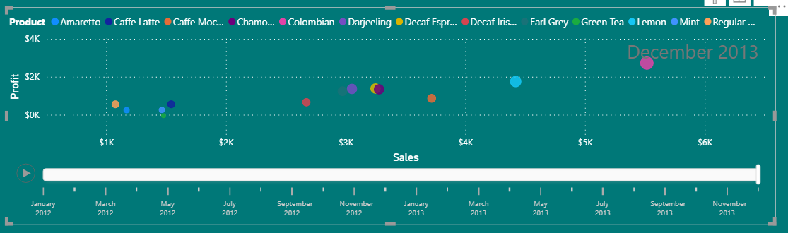

The main reason to use animated chart that it can draw the trend line by relationship changes over the period. It attempts to find the relationship between sales and profit with each product.

## 8.5 Map

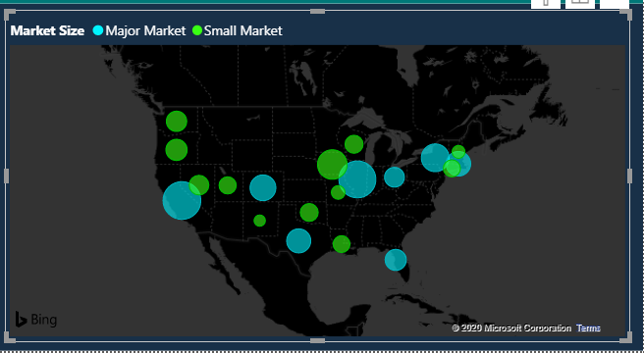

The map can show the distribution of market size and profit by state. It can be easy to find the size of profit depends on the bubble’s size. The state of Iowa even is a small market compare with other big cities, but the profit volume is much better the other major market, like Florida and New York.

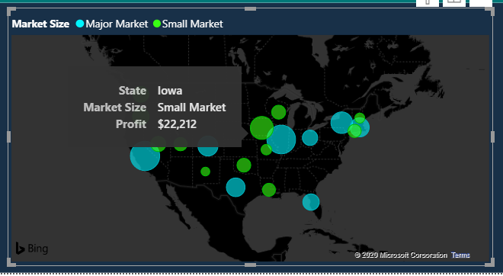

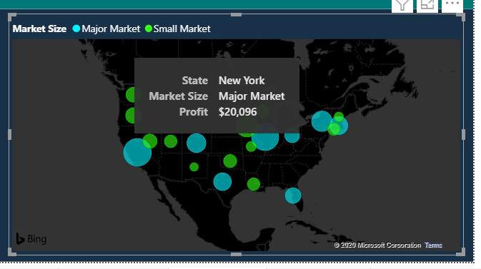

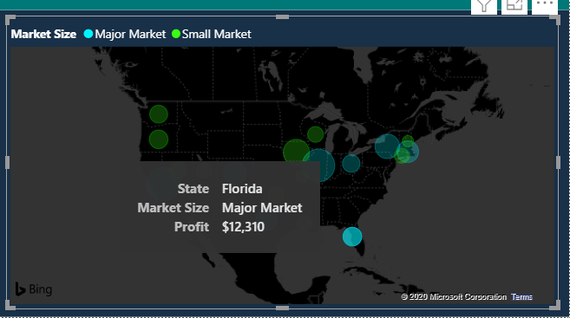

## 8.6 Ask a Question Tool

Ask a question tool is embedded into our dashboard and it is possible to type a question or click a question into the question tool to display the result that someone looking for.

# 9 Data Analytics (Forecast, Analysing trends)

## 9.1 Forecast

Sales volume is one the most important thing that target audience would like to concern, as they desire to forecast the value for further action. Power BI can be able to apply forecasting function into the chart. It can use the data to analysis and predict the coming value for our reference.

Once created the chart, it is available to choose “Analytics” and add “Forecast”. Then, it has the extension at the end of the result, and it is a prediction for your reference. Also, look at the table with numbers which may use it for more details.

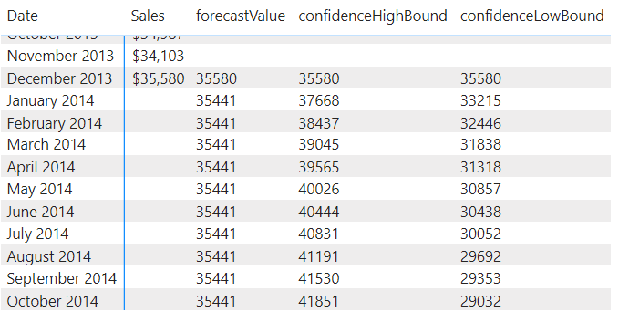

## 9.2 Artificial Intelligence And Key Finding From The Visual

The decomposition tree can visualise data though many dimensions. It can aggregate data and able to drill down into the dimensions in any order automatically. It is an artificial intelligence visualisation, which finds the next dimension to drill down into based on specific criteria.

In the “Explain by” column, choose our own pattern and put the items that desire to analysis in “Analyze” column. As this graph mentioned in the key finding before, Caffe Mocha is the most popular product in the major market of Illinois in 2012 and 2013. Also, it is possible to find many relationships from decomposition tree with different mix and match.

# 10 Structure of the Dashboard

Try to structure the dashboard and the purpose to make it clean and easy to read. It attempts to keep colour and background consistently. Also, it is necessary to put the most important chart on the top and place the others for the rest of area, which it can capture audience attention.

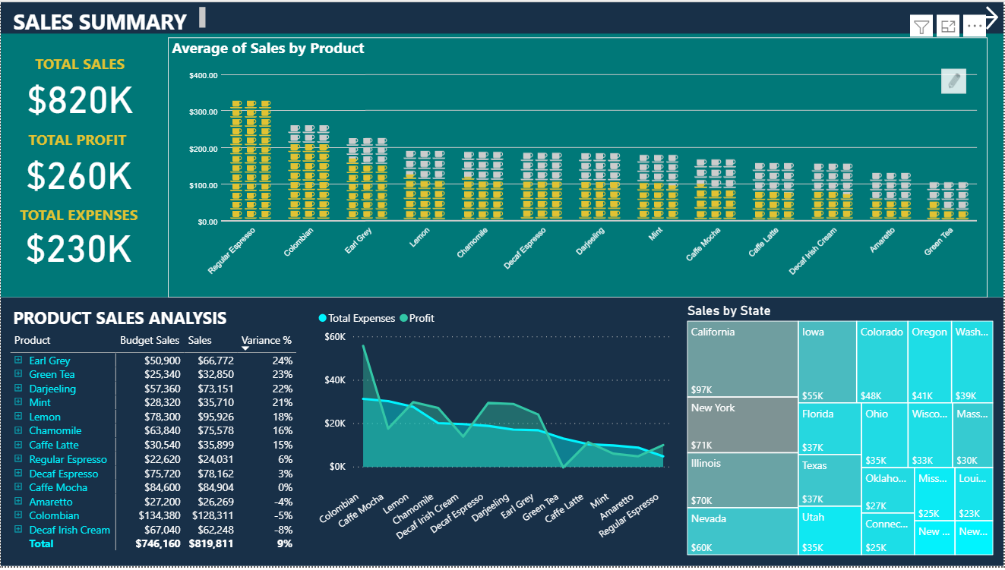

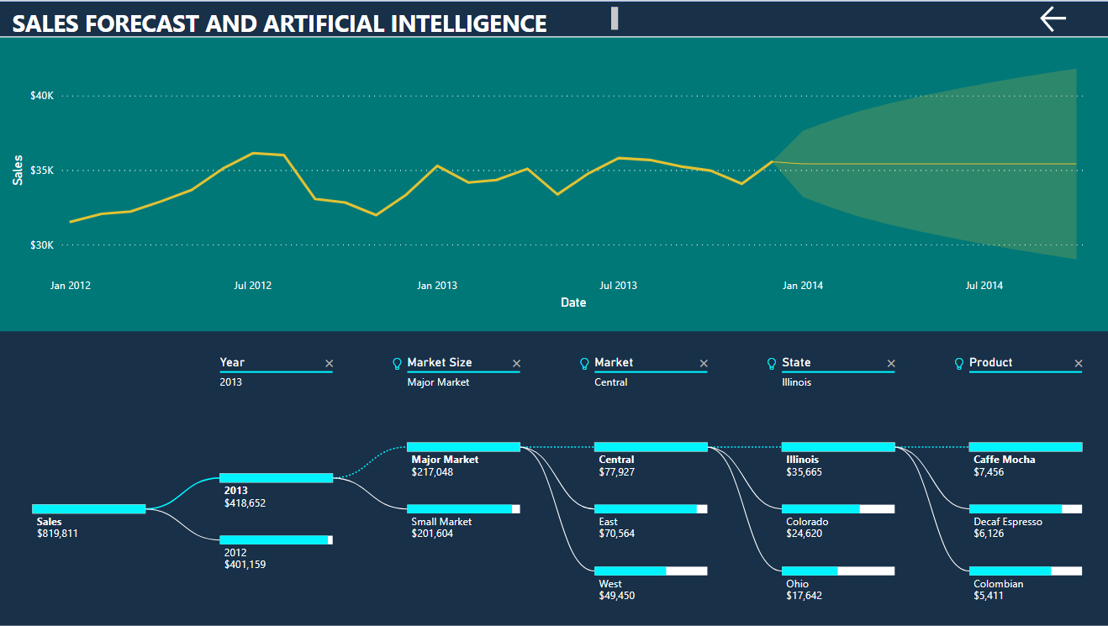

# 11 Conclusion

In this report, it can find some insights with different attributes, which is like the average of sales by product, the variance between budget sales and sales. Also, it illustrates about the relationship with total expenses and profit, and key performance indicator in the dashboard. Sales forecast and artificial intelligence can provide different ideas for management team to make decision. Also, the structure of dashboard can make target audience easy to understand the dataset in a short time.

# 12 Recommendations

From the report, it indicates some products are losing money, which is most of tea products are facing this situation. The possible suggestions may discuss with suppliers, which it may try to control the cost of tea products, or it may consider changing the other products if it does not have good sales volume. A marketing team may also think about a promotion to have a bundle package with coffee and tea, maybe it can boost the sales volume and use the other profit to cover the loss.

# 13 Personal Conclusions

Thank you so much for my module leader Annalisa Occhipinti and module tutor Vishalkumar Thakor with their valuable support and let me know how to make my ICA better.

When I started to do the element one, I faced the problem about making relationship with models. I tried to search from internet and watched the video from Blackboard, but it cannot make me understand to apply in my case. The problem was still not yet solved until my tutor gave me some advices. As I did not have any experience about database, so it was a tough mission for me, and I tried to enquire my tutor. He was using many examples to let me understand and he did not mind following up my process all the time. He makes me learn a lot from his advice and make me feel more comfortable for the ICA.

On the other hand, finding dataset is also one of the most difficult tasks in ICA. The main problem is my first task to do Power BI report and it will be very challenge if I find a dataset’s structure is not well organised and data volume is too large. I attempt to look for the dataset from Microsoft website, but most of datasets for education use only. It is clean and tidy, which means it will be too easy for us to make a report and it cannot fit on the ICA requirement.

# 14 Reference

Microsoft Corporation. 2020. Create and view decomposition tree visuals in Power BI. [Online]. [1 December 2020]. Available from: <https://docs.microsoft.com/en-us/power-bi/visuals/power-bi-visualization-decomposition-tree>

Microsoft Corporation. 2020. Create key performance indicator (KPI) visualizations. [Online]. [5 December 2020]. Available from: <https://docs.microsoft.com/en-us/power-bi/visuals/power-bi-visualization-kpi>

Science direct. 2020. Big Data Problem. [Online]. [5 December 2020]. Available from: <https://www.sciencedirect.com/topics/computer-science/big-data-problem>

April, R. 2013. Big Data Integration. [Online]. [10 December 2020]. Available from: <http://www.sciencedirect.com/science/article/pii/B9780123971678000212>

Microsoft Corporation. 2019. Understand star schema and the importance for Power BI. [Online]. [12 December 2020]. Available from: https://docs.microsoft.com/en-us/power-bi/guidance/star-schema

Microsoft corporation. 2019. Introduction to dashboards for Power BI designers. [Online]. [12 December 2020]. Available from: https://docs.microsoft.com/en-us/power-bi/create-reports/service-dashboards

Nicholas, G. 2020. 15 Best Power BI Dashboard Examples. [Online]. [15 December 2020]. Available from: https://rigorousthemes.com/blog/best-power-bi-dashboard-examples/